

***Generational Wealth Transfer***

***To reserve your spot, please contact (insert name) at (insert phone)***

***or (provide webinar registration link here)***

**In this family planning seminar, learn how you can leave a lasting legacy for your loved ones through wealth transfer best practices. We will discuss:**

* *Why generational wealth transfers are failing*
* *Why planning is essential for transfer success*
* *Tactics for creating an effective plan for your loved ones*

***Hosted By: (Advisor Name, Title, DBA)***

on:

**(DATE) - (TIME AND TIME ZONE)**

at:

**(NAME OF LOCATION)**

(ADDRESS - IF APPLICABLE)

**Jack Smith, CFP®  
Financial Advisor**

123 Sample Way

Sampletown, ST 10000  
O] 555-555-5555

Jack.smith@lpl.com

**JOIN US FOR AN INFORMATIVE SEMINAR**

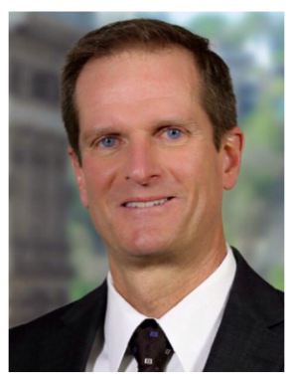

**Securities and advisory services are offered through LPL Financial (LPL), a registered investment advisor and broker/dealer (member FINRA/SIPC).** Insurance products are offered through LPL or its licensed affiliates. Sample Credit Union and Sample Financial Management **are not** registered as a broker/dealer or investment advisor. Registered representatives of LPL offer products and services using Sample Financial Management, and may also be employees of Sample Credit Union. These products and services are being offered through LPL or its affiliates, which are separate entities from and not affiliates of Sample Credit Union or Sample Wealth Management. Securities and insurance offered through LPL or its affiliates are:

**Not Insured by NCUA/FDIC or Any Other Government Agency| Not Credit Union/Bank Guaranteed| Not Credit Union Deposits or Obligations| May Lose Value**