

***Generational Wealth Transfer***

***To reserve your spot, please contact (insert name) at (insert phone)***

***or (provide webinar registration link here)***

**In this family planning seminar, learn how you can leave a lasting legacy for your loved ones through wealth transfer best practices. We will discuss:**

* *Why generational wealth transfers are failing*
* *Why planning is essential for transfer success*
* *Tactics for creating an effective plan for your loved ones*

***Hosted By: (Advisor Name, Title, DBA)***

on:

**(DATE) - (TIME AND TIME ZONE)**

at:

**(NAME OF LOCATION)**

(ADDRESS - IF APPLICABLE)

**JOIN US FOR AN INFORMATIVE SEMINAR**

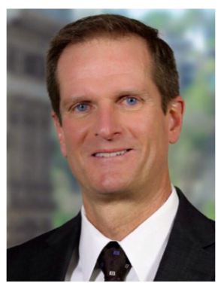

**(Approved standard disclosure goes here)**

**Jack Smith, CFP®  
Financial Advisor**

123 Sample Way

Sampletown, ST 10000  
O] 555-555-5555

Jack.smith@lpl.com